JAIWIN MITHRA A/L SURANDRAN

Adaptable team player with experience in task coordination

and thriving in fast-paced environments. Skilled in attention

to detail and effective collaboration.

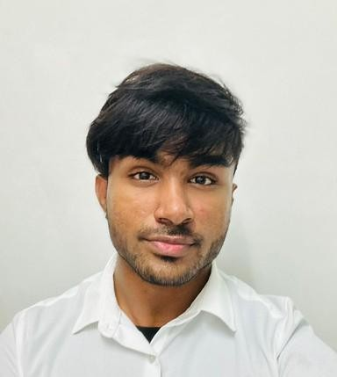

+601126132794

[jaiwin005@gmail.com](mailto:jaiwin005@gmail.com)

[www.linkedin.com/in/jaiwin-mithra](https://www.linkedin.com/in/jaiwin-mithra-307251309/)

67, Lintang Lembah Permai 1, Tanjung Bungah, 11200, Pulau Pinang, Malaysia

# SOFT SKILLS

LEADERSHIP COMMUNICATION TIME MANAGEMENT ADAPTABILITY PROBLEM SOLVING

# TECHNICAL SKILLS

HTML CSS

JAVASCRIPT PHP

C PROGRAMMING PYTHON

MS OFFICE MICROSOFT EXCEL CANVA

# QUALIFICATION

Tunku Abdul Rahman University of Management and Technology, Penang, Malaysia

2023 - Present

Currently pursuing Diploma in Information Technology

SMK Bagan Serai

2018 - 2022

# ACHIEVEMENTS & AWARDS

Tunku Abdul Rahman University of Management and Technology, Penang, Malaysia

TARUMT x GradMalaysia

* Co-organized the Skill Enhancement Module 2024.

Wellness Campaign 2024

* Assistant Head of IT, managing technical requirements and overseeing digital setup.

Indian Cultural Day 2024

* Co-organized the event and served as a key leader.

Penang Goes Orange 2023

* Provided IT support to ensure smooth technology operations during the event.
* Directed and edited event videos.

Team Building 2023 - Team Thrive Unite

* Served as Student Leader, guiding team activities and promoting collaboration.

# EXPERIENCE



LANGUAGE ABILITIES

ENGLISH

BAHASA MALAYSIA TAMIL INDONESIAN

HOBBIES

* WORKING OUT
* CYCLING
* HIKING
* PHOTOGRAPHY
* COMPUTER PROGRAMMING

References

Ms. Hanyusha

Relationship: Business Associate

Phone Number: 010-802 4445

Ms. Hanyusha

Relationship: Business Associate

Phone Number: 010-802 4445

Mr. Narresh

Relationship: Team Member

Phone Number: 016-504 5678

JAIWIN MITHRA A/L SURANDRAN

Business Social Media Management (2024 - present)

* + Experienced in product development in

watch Modifications.

* + Social media management for brand growth

and engagement.

* + Content planning and creation.

Swaranjali 2024

* + Marketing for Cultural Music Concert (Swaranjali 2024) in collaboration with Episode Events.
  + Perform ticket sales and managed social media.

E-Commerce Website (2023)

* + Language: HTML, CSS, JavaScript
  + Project Duration: 3 months
  + Content: Developed a website focused on jewelry products.

Client-Server Web Application (2023)

* + Language: HTML, CSS, JavaScript, PHP
  + Project Duration: 3 Months
  + Content: Developed a web application with client-side and server-side scripting

MS SOOK FONG CHO

Relationship: Lecturer

Email: chosf@tarc.edu.my